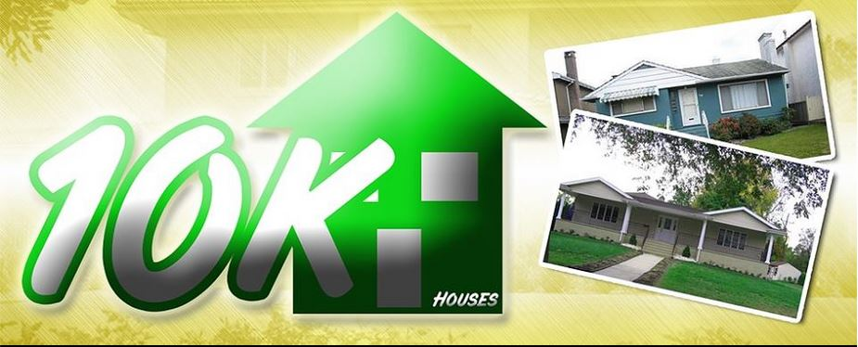
Homesfor10k Offer Chart

Cash offer chart for td & tn llc offers on behalf of homes for 10k

Raleigh offer chart
Every property in Raleigh offer $9k to $11k or lower for any value

Frayser offer chart
Every property in Frayser offer $9k to 10k if value is $35k on Zillow or higher
Every property in Frayser offer $3k to 5k if value is $20k to $30k on Zillow

East Memphis offer chart
Every property in 38118 offer $13k to $15k
Every property in 38115 offer $11k

Whitehaven offer chart
Every property in 38116 $15k

Hickorty Hill East Memphis offer chart
Every property in 38125 if the value is $140k+ offer $85k and counter to $105k max
Every property in 38141 if the value is $85k to $100k offer $49k

Cordova, Germantown, Bartlett, Collierville offer chart
Every property in suburbs if the value is $65k to $85k on assessor site or Zillow offer $35k
Every property in suburbs if the value is $125k on assessor site or Zillow offer $75k
Every property in suburbs if the value is $140k to $150k on assessor site or Zillow offer $102k
Every property in suburbs if the value is $160k to $180k on assessor site or Zillow offer $110k
Every property in suburbs if the value is $160k to $180k on assessor site or Zillow offer $110k
Every property in suburbs if the value is $200k on assessor site or Zillow offer $135k
Every property in suburbs if the value is $250k on assessor site or Zillow offer $150k

